Date: 20 September 2026
Author: Shashank Kaveti

Design Document for V0

- Overview
Mobile app that helps the user keep track of their daily tasks. These tasks are tied to improving the user’s mental or physical health and automatically repeat daily. Each task is worth a certain number of points and by completing the tasks, the user can earn these points. Earning enough number of points will allow the user to “level up.” My goal is to inspire people to work on themselves and grow as human beings. By gamifying self-improvement, we can make this process fun and easy!
- Scope, functionality, and features
  - Version 0 has just 1 user (me)
  - Limited to 2 growth areas:
    - Mental
    - Physical
  - Very simplistic UI and levelling system
  - 2-page app:
    - “Daily tasks” screen:
      - To-do list that contains the daily tasks
      - Looks and feels similar to the “Reminders” app in iOS
      - Progress bar at the bottom of the screen that shows the progress to the next level
    - “Task creation” screen:
      - User can create a task and tie to a growth area: mental, physical, or general
      - User can also enter the number of points it is worth, specify the date and time for the task to become active/visible, and set it to repeat (or not)
  - Test/dev mode for testing- should contain controls to allow the level progress to reset to “0”
    - Hidden behind a small button on the bottom left of the screen
- UI mockups
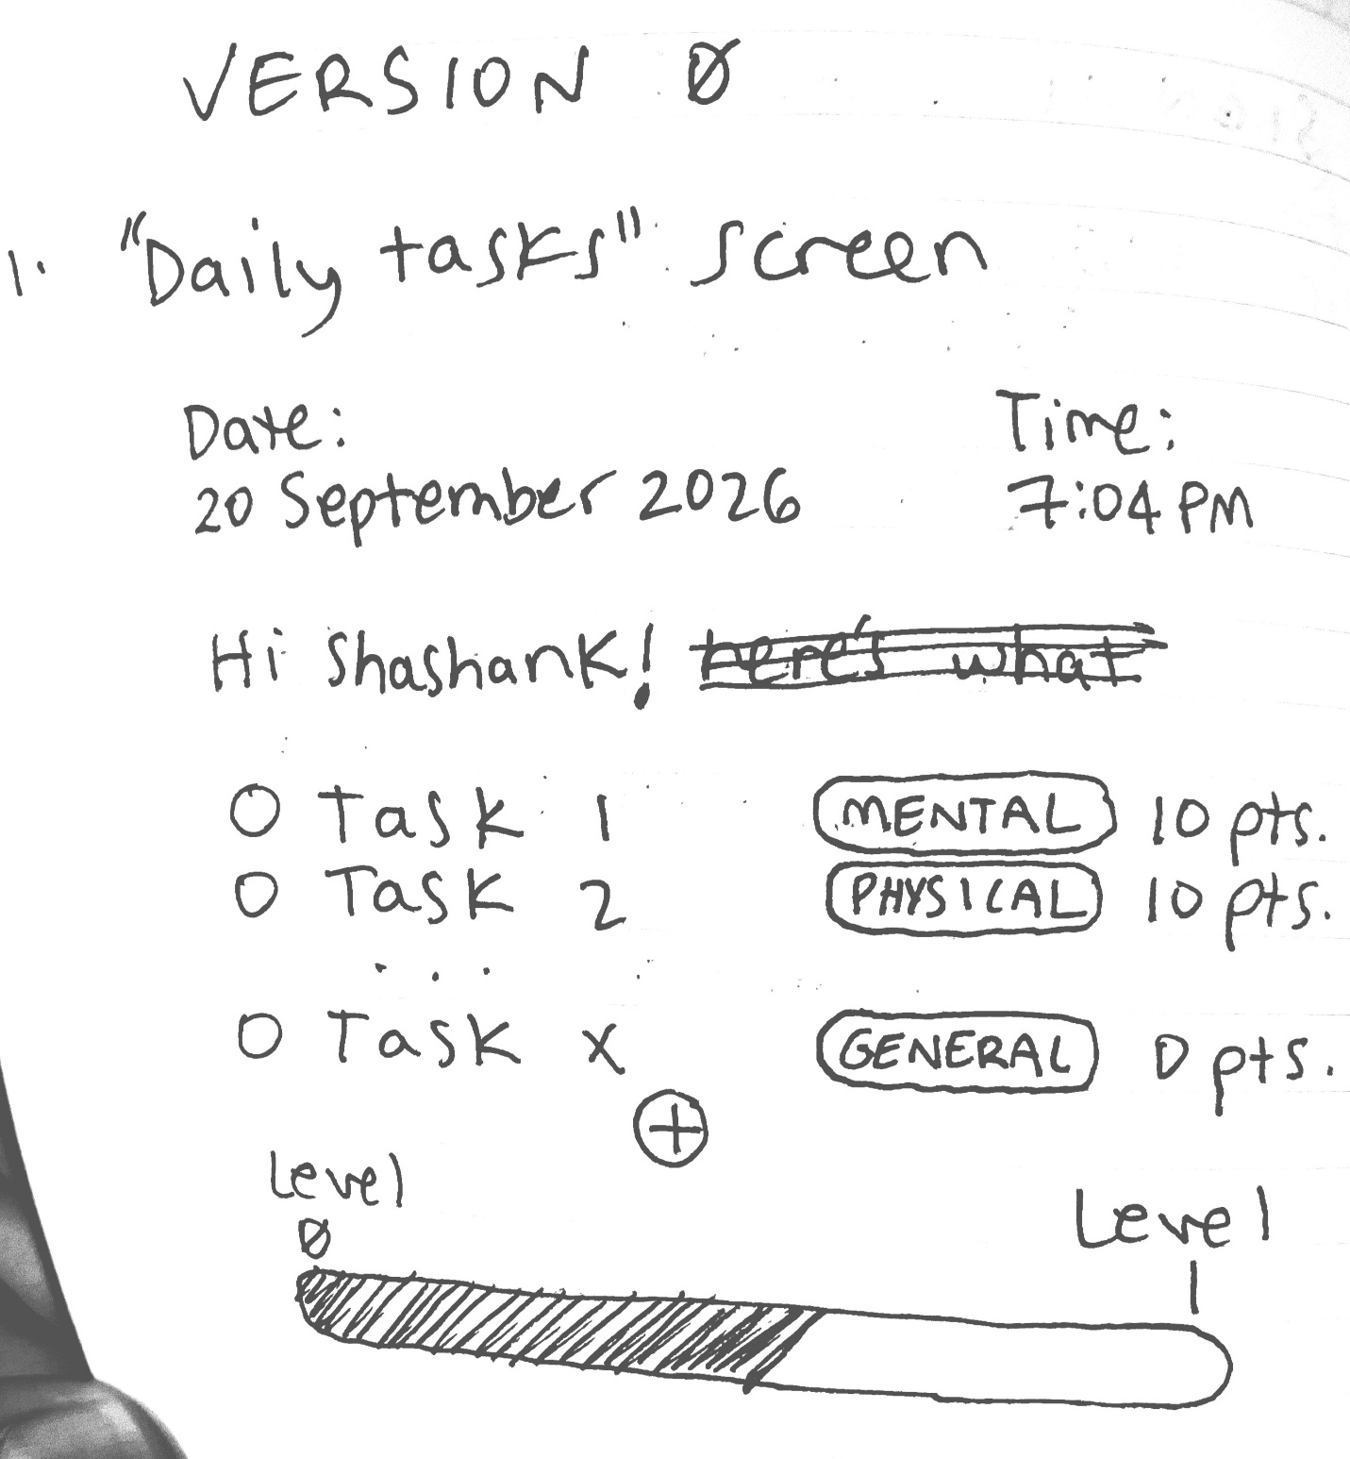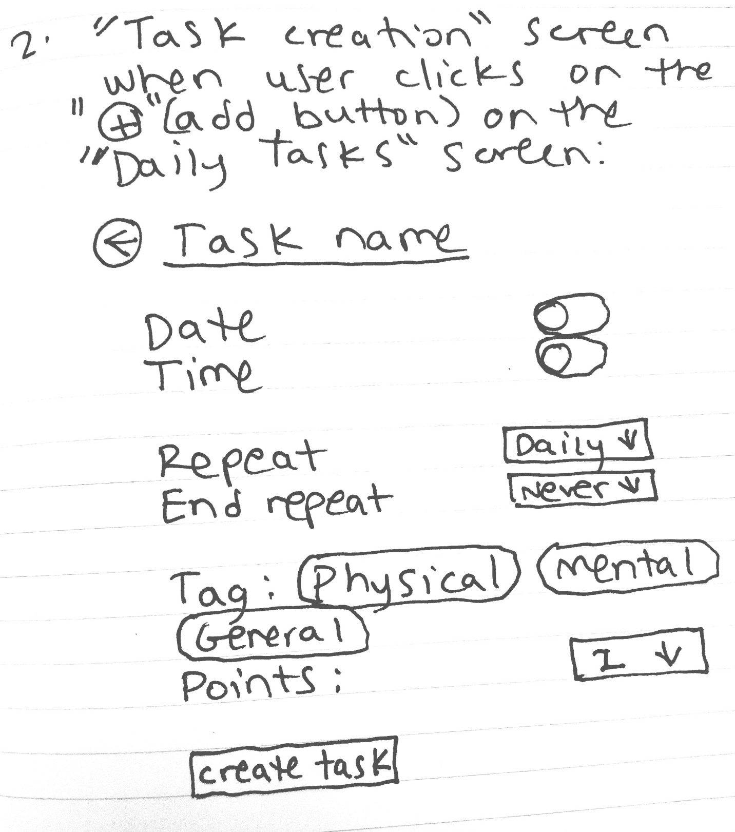
- Architecture
  - Since the scale is small, we can start with just the UI
  - Recommend a good architecture to scale to accommodate more users, more growth areas, and more features (but don’t need to do it all today)

